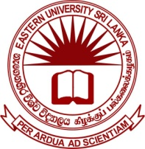

**EASTERN UNIVERSITY, SRI LANKA**

**WALK-IN INTERVIEW FOR TEMPORARY ASSISTANT LECTURERS IN PHYSICS**

Eligible candidates are invited to attend a walk-in interviewfor the posts of **Temporary Assistant Lecturer** in the **Department of Physics**, Eastern University, Sri Lanka on **Monday, 18th January 2016 at 10.00 am**.

***Qualifications:***

* Special Degree in Physics with a Class

Interested candidates may appear in the walk-in interview in the Board Room of Faculty of Science with updated curriculum vitae (CV) and supportive original documents/certificates.

HEAD/DEPARTMENT OF PHYSICS

EASTERN UNIVERSITY, SRI LANKA

VANTHARUMOOLAI,

CHENKALADY

04.01.2016